How to access server  
1. Login to Digital Ocean and go to console like below.

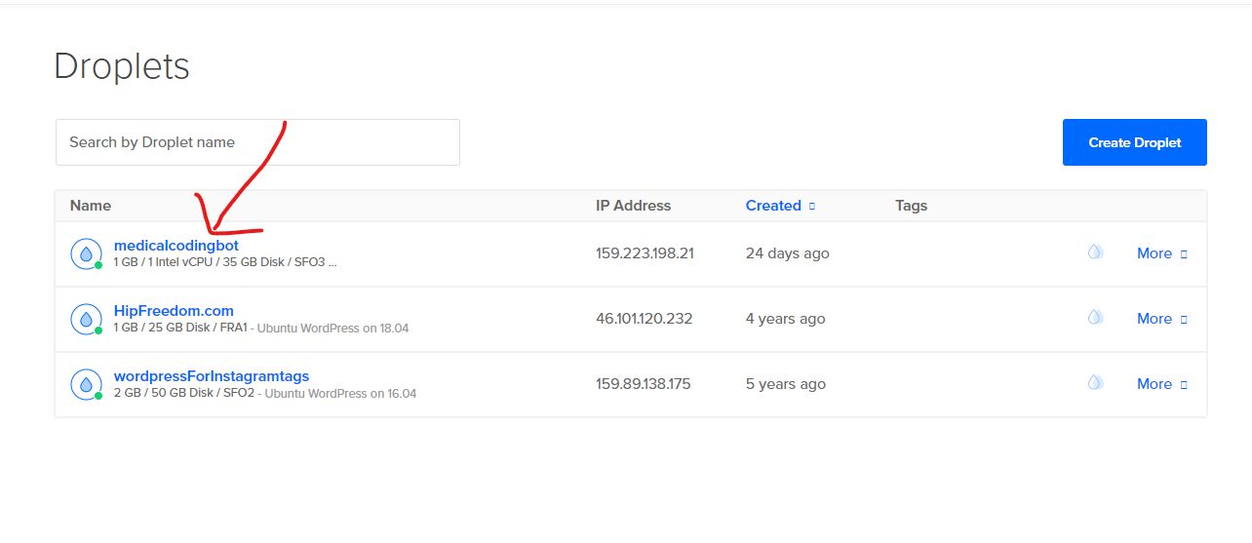

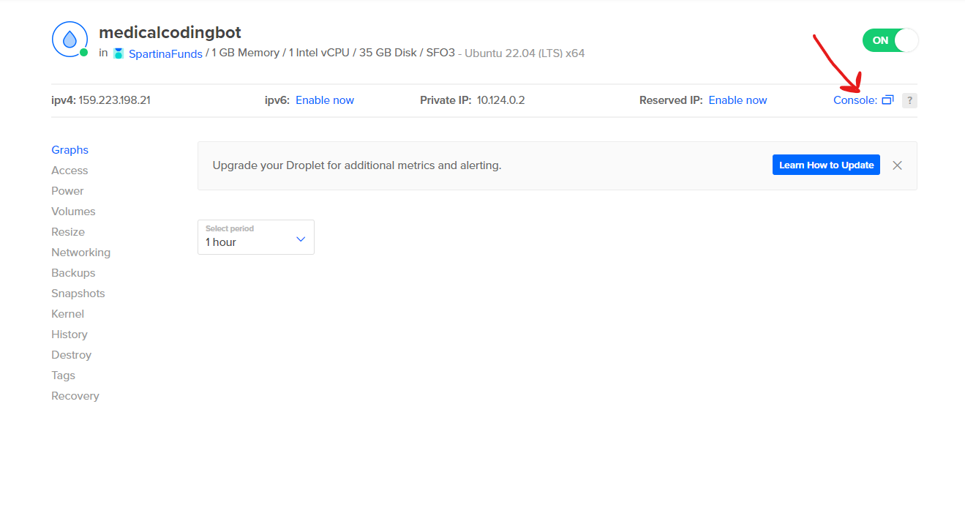

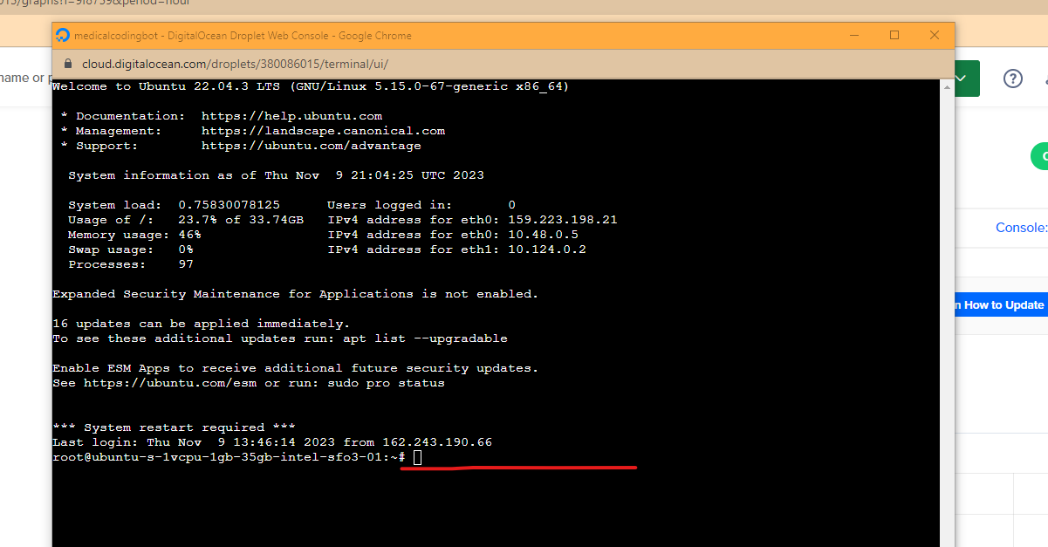

2. How to run frontend server  
Start: sudo service nginx start  
Stop: sudo service nginx stop

Restart: sudo service nginx restart  
  
3. How to run backend server  
Start: sudo systemctl start medicalcodingbot

Stop: sudo systemctl stop medicalcodingbot

Restart: sudo systemctl restart medicalcodingbot